

f14g26 - User’s Guide

IDS 517 – Enterprise Application Document

|  |  |
| --- | --- |
| Group Members | |
| Krishnakanth Panakarajupally | kpanak2@uic.edu |
| Ganesh Satyamsetti | gsatya2@uic.edu |
| Sreekanth Chinthagunta | schint9@uic.edu |
| Siddhartha Varma Gadiraju | sgadir2@uic.edu |

Contents

Login Page 3

Admin Page 3

Registration Page 4

Normal User Page 5

User Data Upload Page 6

Export Table Page 9

Data Analysis Page 9

Scatterplot 11

Regression Line 12

Logout 13

# Login Page

If you have your user or admin login credentials then you can put them andhit login button. If this is your first time using our application, you will have to *click “here”* for new user registration as shown later.

If you have been granted administrator access, the application will validate that and direct you tothe administrator page. Otherwise, you will be directed to the site that all general users use.

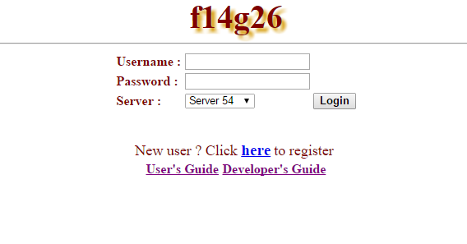

# Admin Page

Admin page has Home, Admin Tools, Examine Tables, Import Data, Session Info and Logout as listed in the screen shot.

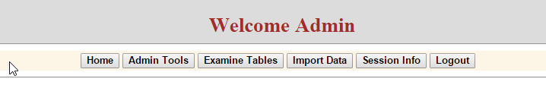

Admin tools page has the following options:

Admin can

1. View the Users registered in the application
2. See User Activity
3. Create User Table
4. Create Log Table to save the user session information
5. Drop User and Log Tables

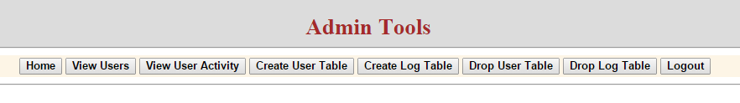

# Registration Page

You will be redirected to the Register page. From here, you will input all the credentials required and click “Register”.

After you have done so, you will be directed to the login page shown above.

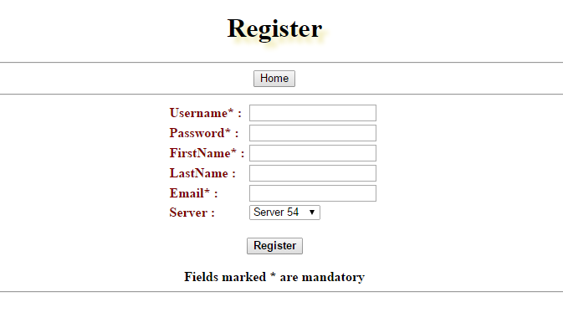

# Normal User Page

Once registered, use these credentials to log in as a normal user.

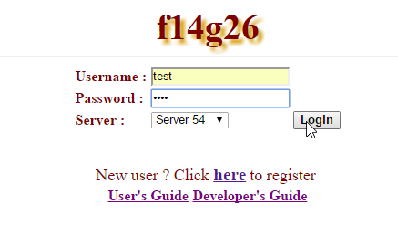

After successful login, the user will see the Welcome screen where user can

1. Import Data from Local Disk
2. Check database connection by using the Session Info option
3. Examine the tables of the imported file

Once user enters the examine tables, additional operations can be performed that are discussed later.

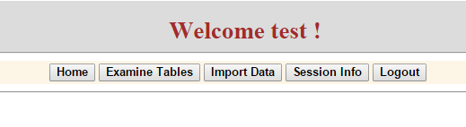

# User Data Upload Page

For analyzing, the file needs to be imported. The file can be imported by clicking “Import Data” button, which directs to the following page.

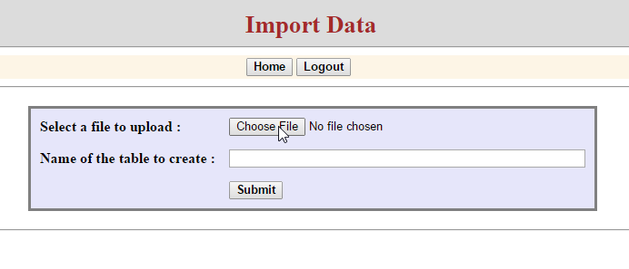

**Selection of data for Upload**

After clicking Import Data, the user will be directed to the following page, where user can select the file that needs to be analyzed, through a browser window that opens up automatically.

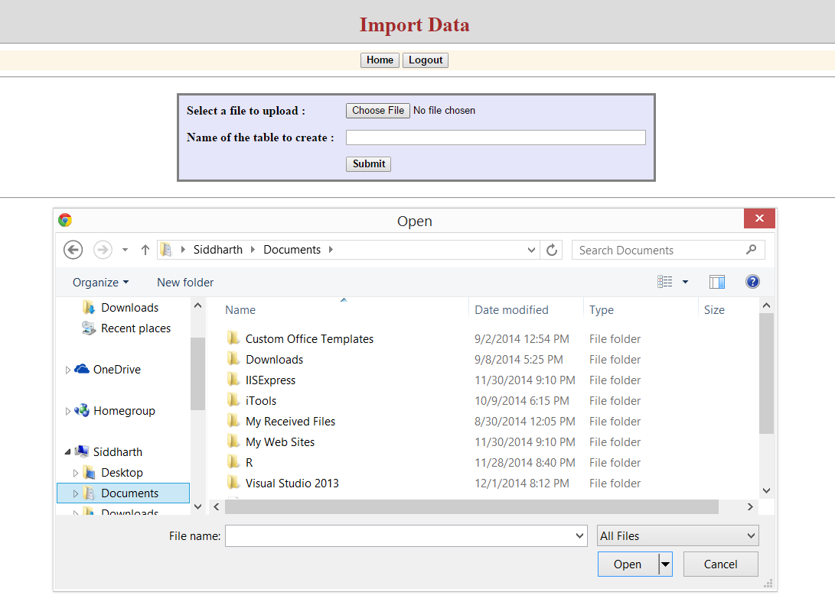

**Data Upload Page**

The uploaded file headers will be displayed as shown below. In this page the user has the option to change the data type of the headers by selecting the drop down list “DataTypeList”. After that, user can click on “Import”.

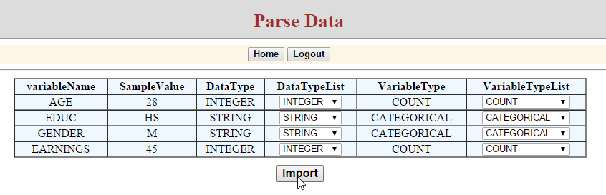

Once the import is successful, the following screen will be displayed with the successful message.

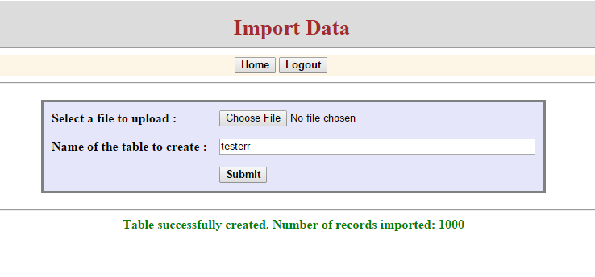

Once the file has been successfully imported, the user can go to Home page and click on Examine Tables to start analyzing the data. User needs to select the required table from a drop down list “Select a Table” and click on Display Data for the data to be displayed. User has the option to drop the table, export data and perform analysis.

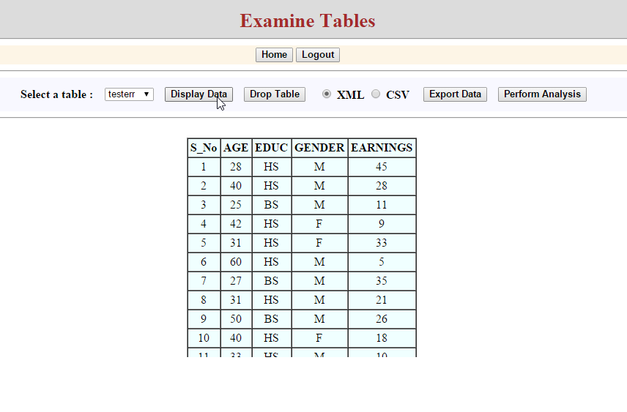

# Export Table Page

Once the table is selected, user can save the file to Local Disk by clicking “Export Data”. Once the button is clicked, user can select path where the file is to be saved.

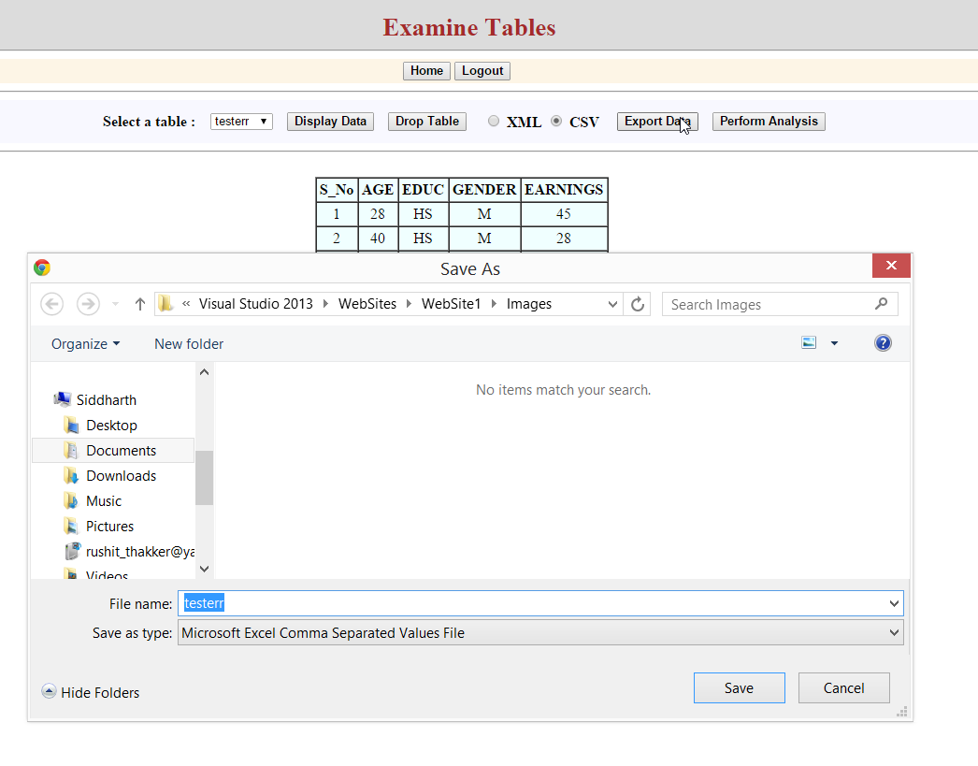

# Data Analysis Page

To analyze the data, the user can click on Perform Analysis button which prompts to the following page. The user can select the columns on which the following mathematical operations can be performed:

1. Minimum – This gives the minimum value of the selected column.
2. 25% (Q1) – It gives the first Quantile deviation of the selected column.
3. 50% (Median) – It gives the median of the selected column.
4. 75% (Q3) – It gives the third Quantile deviation of the selected column.
5. Maximum – This gives the maximum value of the selected column.
6. Mean – This gives the mean of the selected column.
7. Standard Deviation – This gives the standard deviation of the selected colum.

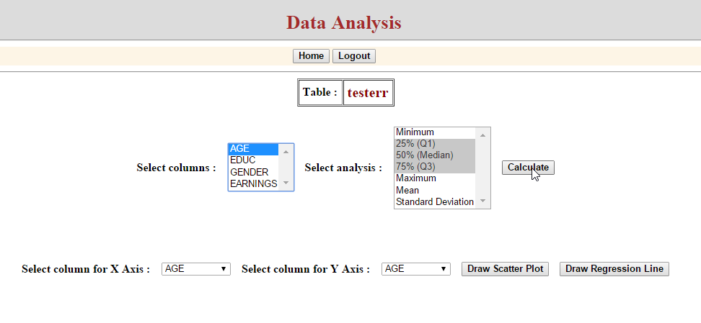

Once the “Calculate” is clicked, the following screen will be displayed with the result.

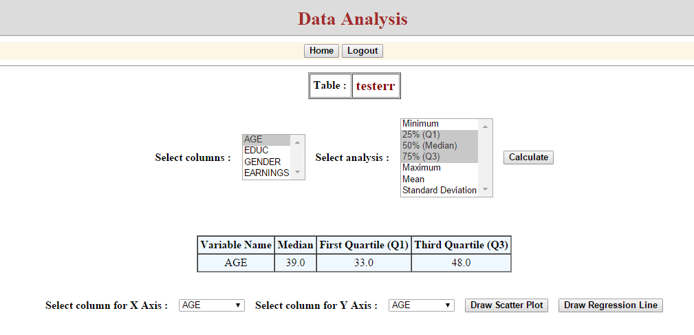

# Scatterplot

To get the scatterplot, the user can select the X and Y axes by selecting the respective fields. After clicking “Draw Scatter Plot”, the following screen will be displayed.

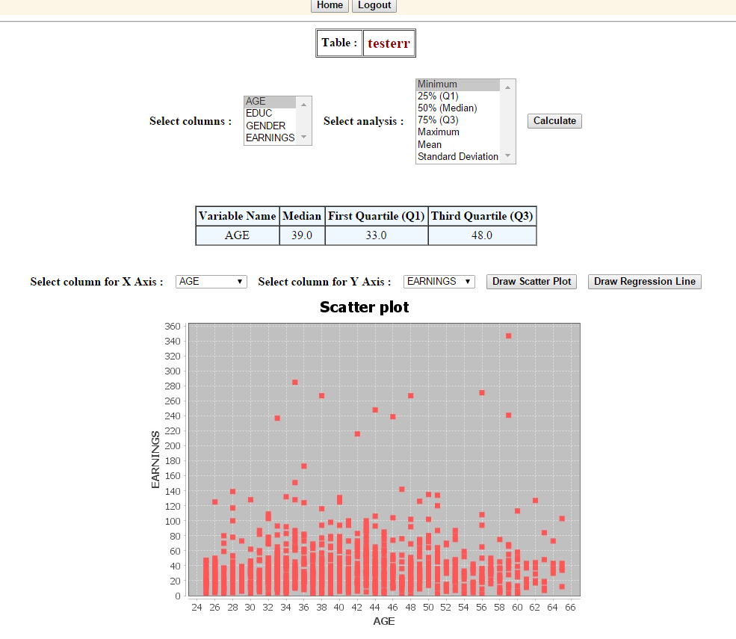

# Regression Line

To get Regression line for the Scatter Plot, user needs to click on the “Draw Regression Line” button. This will show the regression analysis of the data along with the regression line equation.

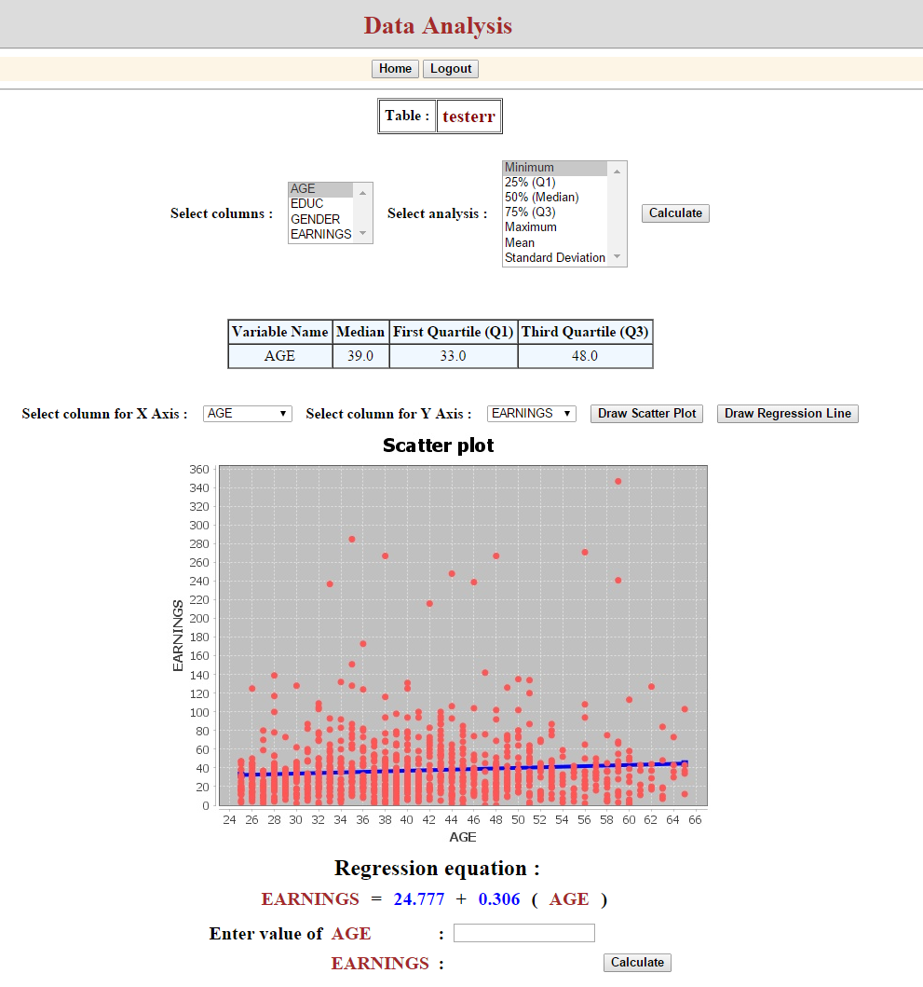

# Logout

The user can end the session by clicking “Logout” button, which prompts the following window to confirm the session termination.

